
SOUTH AUSTRALIAN GEOGRAPHY PHOTO COMPETITION 2026
Year 7-9

Theme: Planning for the Future

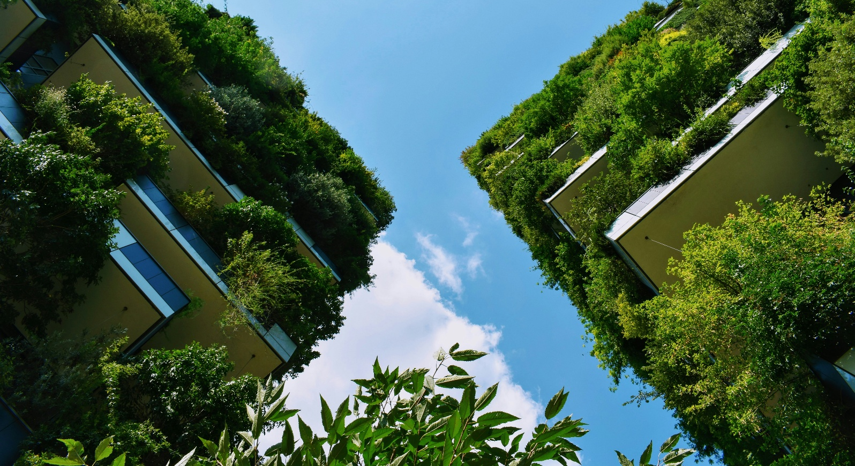

Capture how South Australia is preparing its people, places and environments for change.
In <100 words describe your photo’s connection to the theme.
Winning prize: $100
Shortlisted photos to be displayed in Adelaide Town Hall

